Triton Logger Remora

The Triton Remoras pulldown menu has a log submenu that is used for starting the logging functionality. The New log and Continue existing log options are used to start logging sessions.

Starting a log
When New log is selected, a dialog will ask for where the log file will be stored, and will then ask for information about the data that will be deployed:

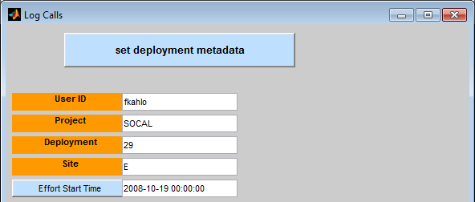

User ID should be your first initial and last name, e.g. fkahlo for Frida Kahlo. When possible, logger will fill in the project, deployment, and site based on the audio files that you currently have open in Triton.

If the logger can determine the Project, Deployment, and Site, it will populate Effort Start Time to the start of the deployment based on a query to the Tethys database. This time can be changed to any appropriate time by clicking in a plot window or editing the date manually. Pressing the blue Effort Start Time button will restore the time to the default value. Press the set deployment metadata button to proceed to specifying which species and calls will be part of your effort:

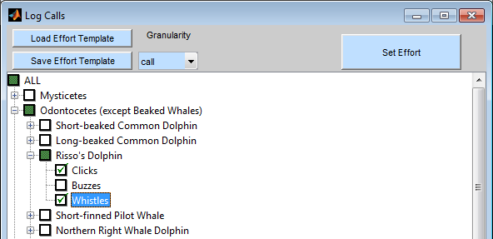

The plus/minus buttons can be used to expand/collapse the tree. Granularity specifies how the calls are being selected. The options are:

- call – Individual calls are logged
- encounter – The start and end of an acoustic encounter is logged.
- binned – Presence/absence within some interval is logged. When binned is selected, the bin width must be specified in minutes and must divide evenly into a day (1,440 m). It is assumed that bins start at midnight.

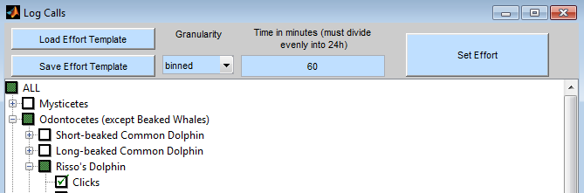.
All calls in a logging session must use the same granularity. Once the settings are selected, they can be saved with the Save Effort Template button, or an old set can be loaded with Load Effort Template. Once the selections are made, press Set Effort to start logging.
Continuing a log
To continue a log that had been started earlier, select Continue existing log from the tools→log menu.
Logging
Once logging has started, the log window will appear as follows:
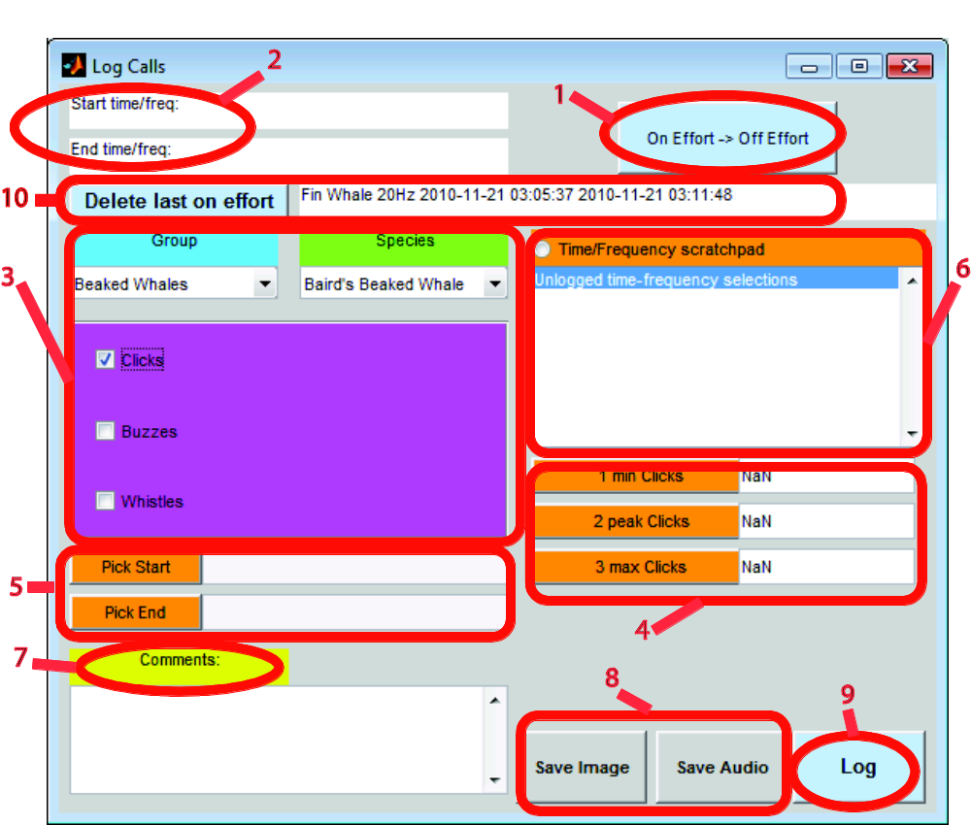

- On/Off effort. The interface starts in on effort mode. Only calls that were selected as part of the effort can be logged during this time. If an analyst notices something interesting that is not part of the effort, the analyst can go off effort by pressing this button. All species and call types will become available, and the logger panel’s background will be set to a bright color to remind the analyst that they are in off effort mode. After logging the off species effort, the same button can be pressed to return to on effort. It is very important to remember to switch back to on effort for species that are part of the effort.
- Start and End time/frequency. A time/frequency bounding box can be selected by holding the mouse button and dragging out a rectangle. The upper left corner of the box is reported in the start time/frequency and the lower right in the end/freq. When a user simply clicks, the time/frequency point is treated as a degenerate rectangle and the same point is copied to both fields.
Note that the times and frequencies selected are not copied automatically to the pick start/end fields. See point 5 for information on how to do this. TODO
- Groups, species and call types. This section allows a user to specify a species and call type. The group pulldown allows one to select a group of species such as mysticetes or anthropogenic sound. The species menu will be dependent upon the current selection of the group. A set of call type checkboxes will be displayed for each species.
- Parameters. These consist of parameters that are associated to the call type currently selected. Parameters are defined in the call type template and are call specific. Parameter values can either be typed in manually, or you can either click on the button to the parameter’s left or type the button number in the plot window. The two latter methods will copy the last selected frequency displayed in the Start time.
- Pick Start/End: This records the start and end time of a frequency being recorded. To use: Click the “Pick Start” button to record the start time. Then click the “Pick End” button to record the end time. You can also use the hotkey: “S” for Pick Start and “E” for Pick End, or “B” for both start and end. The B option will also update any parameters with the name min and max based upon the current bounding box.
- Time/Frequency scratchpad: When selected, time/frequency picks are displayed in the list box below the title. These times and frequencies are not logged and are for analyst information only. This function can be enabled/disabled by clicking on the button or using the hotkey “F”.
- Comments: Use this section to write down any comments you might have for this particular data.
- Save Image/Audio. Data associated with the current screen will be saved as an image or audio and associated with the log. Audio is only saved if the user is displaying a waveform and is not available for long term spectral averages. At any point prior to logging the event, the user can change their mind and clear the image/audio by pressing these buttons a second time.
- Log: After you have picked all the data you wanted to press “Log” to save the data onto the logfile. The following fields need to be filled before logging data into the logfile: CallType, Pick Start/End..
- Previous Pick: after Logging data into the logfile all the fields will clear and the newly added log will appear in Previous Pick. The previous log entry can be deleted by pressing on the “Delete…” button.
While the logger is open, it is possible to show the workbook that is being logged. Select Toggle workbook visibility from the tools→log menu to display or hid the workbook. Never close a visible workbook by closing Excel, it will break the functionality of the logger.

Creating custom hotkeys
Once logging has begun, one can add new hotkeys that will be saved for future sessions. From the tools menu, select log and then “Add hotkey.” The following dialog will be shown:

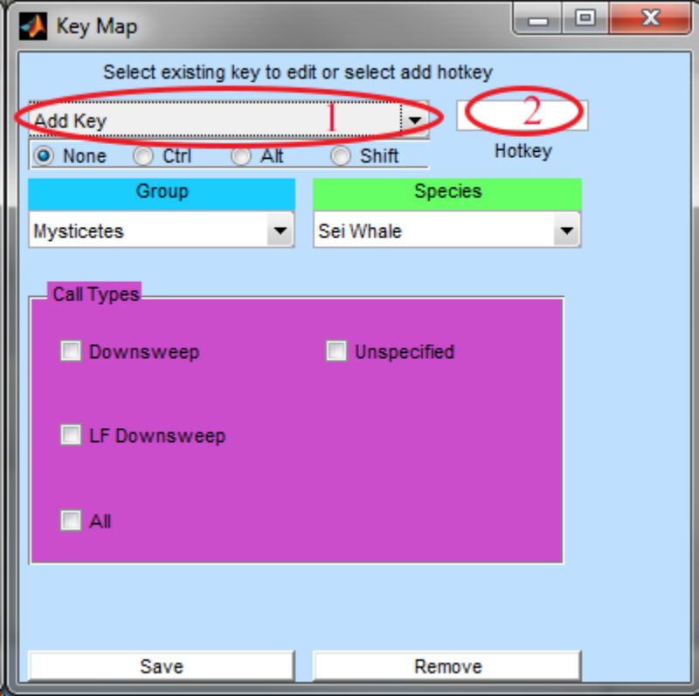
The drop down menu (1) allows the definition of new hotkeys or the editing/removal of existing ones. To create a new binding, select the species and call that to be used. For example, to bind d to blue whale D calls, select the following:
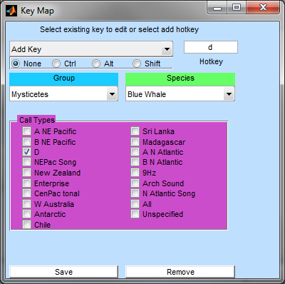
Exisiting bindings can be modified by selecting them from the drop down menu and either pressing Remove or changing the hotkey.

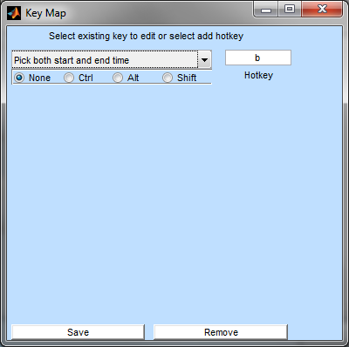

When you press Save, the bindings are written to a file called keymap.xml in the triton logger folder. When upgrading triton logger, you may wish to copy your keymap.xml into the new logger folder to retain your customizations.
The default keymap contains the following hotkeys:
Motion controls, hold CONTROL to affect LTSA plot
→ | advance
← | rewind
^ | automatic advance
v | automatic rewind
space | stop automatic advance/rewind
Logging controls
a | save audio
b | pick both start and end
f | toggle pick frequency
s | pick start
e | pick end
i | save image
l | log
1-6 | set n^{th} parameter
Window functions – Hold Shift
1 | Bring Triton windows to foreground
l | Bring logger window to foreground

Closing the logger
Press the close box on the log window. A dialog box will allow the user to pick an end of effort from predefined values such as the latest pick or the user can select to specify end of effort themselves. In this case, if logger was able to determine the end of the deployment it will be the default value, and like start of effort, can be restored at any time by pressing the Effort End Time button. The end of effort from the last time the log was closed (if applicable) and the date of the last detection will also be shown:
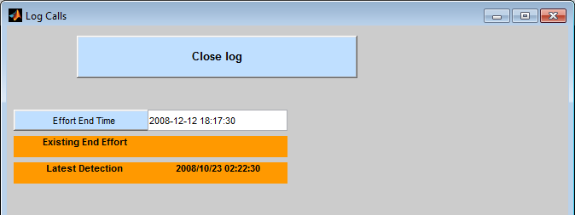
The Effort End Time can be typed manually or selected by clicking on a plot. When satisfied, press Close log.

Submitting a workbook
Once a log is complete, it can be uploaded to the Tethys database by selecting Tools→log→Submit log.

Set up a logging template
The folder where triton is installed will contain a “log_data” folder which is where Triton looks for a template Excel workbook called Detection_Effort_Template.xls. This file may be customized or replaced to change the species names and calls. A template should have five sheets: Detections, AdhocDetections, Effort, MetaData, and References.
Detections will be where all the detections recorder by the analyst while using the logger. See the template for what information specifically is collected for each detection the analyst makes.
AdhocDetections is where all off effort detections made by the analyst are recorded.
Effort is the list of all the species/call combinations that the analyst is interested in logging, as determined by the selection screen.
MetaData logging session metadata is stored here.
References will populate with references relevant to the effort types selected.

Error messages/effort template formatting
There are a number of error messages that will display to the messages panel if inconsistencies are found between the effort template (in the Effort tab of the above mentioned spreadsheet) and what the program expects to see. The program is built to handle many common inconsistencies but if you experience any weird behavior or missing effort types compared to what was selected when starting a new log, refer to the messages displayed in the message window to get an idea of what’s wrong.

Mismatch in species code: displays when the template has different species codes within the same species. The error message will also contain line numbers to point you to the error in the template.
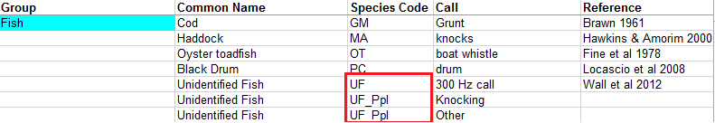

Mismatch in common names: displays when the template has different common names within the same species. The error message will also contain line numbers to point you to the error in the template.
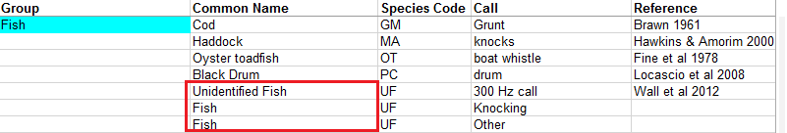
Missing data: displays when the template has a missing common name or species code within a certain species. The error message will also contain line numbers to point you to the error in the template.
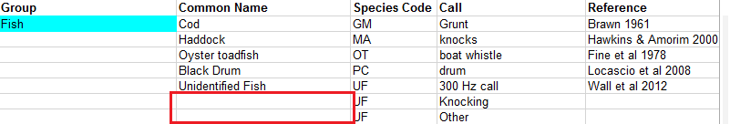
Other known template errors:
There is no error message that is displayed for this, but entries within the same species must not have any blank rows between them, otherwise there will be resulting errors in the effort selection screen and in the creation of the log. Avoid adding white space within species entries or the logger will not work.
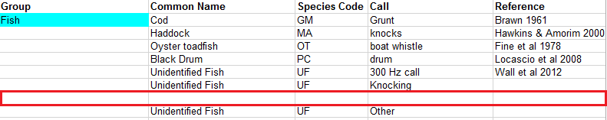
The safest thing to do if trying to alter the template in any way is to follow its format exactly. This is the best way to avoid strange behavior. Additional messages indicating which lines are being deleted from the effort template when creating a new log can be turned on by setting the ‘debug’ variable at the top of writeEffort.m to ‘true’ before running the Logger.

Fairlie Reese 2017

